Supplementary Information.

Methods

Liquid culture growth inhibition assays

To compare the activities of ASM1 and GccF, liquid culture-based growth inhibition assays were carried out using a modification of the previous method [1]. An overnight culture of *Lb. plantarum* ATCC 8014 (MRS medium (Merck), 30˚C) was diluted in MRS medium to an O.D.600 nm < 0.05 and 3 mL aliquots transferred to 4 mL cuvettes in the temperature controlled multi-sample holder of a Varian Cary™ 300 Bio set to 30 °C. Once O.D.600 nm reached 0.1, GccF or ASM1 was added from a concentrated stock and mixed by gentle pipetting to give final concentrations between 0.3 and 1.4 nM GccF, and between 0.5 and 2.5 nM ASM1. O.D.600 nm values were then recorded every minute for 400 minutes. For each culture the maximum % inhibition compared to an uninhibited control culture was determined and plotted against glycocin (GccF or ASM1) concentration. Each data point represents a single experiment.

Genomic DNA extraction

A 1 mL overnight culture of *Lactobacillus plantarum* A-1 [2] was used to inoculate 35 mL of sterile MRS media, which was then incubated at 30˚C until the O.D.600 nm reached 2.0. Cells were harvested by centrifugation at 4,000 x g for 10 minutes at 4˚C, and the pellet resuspended in 2 mL of ice-cold 50 mM EDTA (pH 7.8) containing 10 mM Tris-HCl (pH 8). The 2 mL cell suspension was divided equally between two 1.5 mL microfuge tubes and 400 µL of 40 mg/mL lysozyme (in the same cell pellet resuspension buffer) added to each tube, resulting in a final lysozyme concentration of 11.4 mg/mL. Both tubes were then incubated at 37˚C for 1 hour, mixing by inversion every 10 minutes. Each suspension was then centrifuged at 10,000 x g for 1 minute and the supernatants removed by pipette. Each pellet was re-suspended (by vigorous pipetting) in 800 µL of Nuclei Lysis Solution (Promega Wizard Genomic DNA Purification kit; A1120) at RT, and then subjected to 3 cycles of freeze/thaw by storing in the -80 °C freezer for 10 minutes before placing in an 80 °C heat block for 3 minutes. The tubes were cooled to ~35˚C before the addition of 5 µL of 4 mg/mL RNAse solution (A1120 kit) and incubated at 37˚C for 45 minutes, mixing by inversion every 15 minutes. The tubes were then chilled on ice before the addition of 270 µL of protein precipitation solution (A1120) at RT and thorough mixing by inversion. The tubes were then incubated on ice for 5 minutes before insoluble material was pelleted by centrifugation (17,000 x g, 5 minutes at RT). The supernatant was collected and re-centrifuged at 17,000 x g for 3 minutes. This step was repeated until the resulting supernatant of ~800 µL was completely free of insoluble material. At this stage 620 µL of isopropanol was added and the tubes were mixed by inversion until DNA threads were visible. These were pelleted by centrifugation at 17,000 x g for 5 minutes after which the pellets were washed twice with 70% (v/v) ethanol, air dried and dissolved in 20 – 40 µL 10 mM Tris-HCl pH 8.5. gDNA solutions were quantified using a Nanodrop ND1000 instrument (Thermo Scientific).

Results

Table S1. CID / ECD fragmentation of chemically deglycosylated ASM1; Ser18 as dehydroSer (-18), and Cys43 glycosylated by HexNAc (GlcNAc; +203)



The y ion corresponding to a residual mass difference of 69, (dehydroserine, formed as a consequence of β-elimination at Ser18) is underlined.

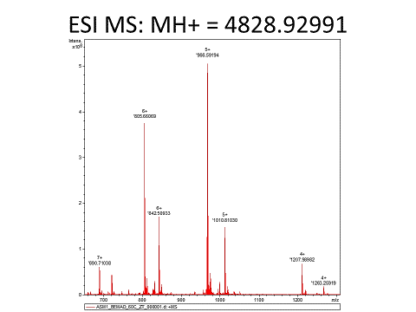

5+

966.59154

5+

1010.81030.59154

6+

805.66069

6+

842.50933

7+

690.71038

4+

1207.98982

glycosylated

Chemically deglycosylated

700

800

900

1200

1100

1000

1300

0

1

2

3

4

5

Intens

X 108

Figure S1. Mass spectrum of the chemically mono-*O*-deglycosylated ASM1. The pairs of peaks represent the native and the chemically deglycosylated species with a mass difference of 221.0938 amu which represents the loss of a HexNAc plus water from Ser18 to form dehydroserine. The mass of the dehydro-deglycosylated MH+ species is 4828.92991 amu.

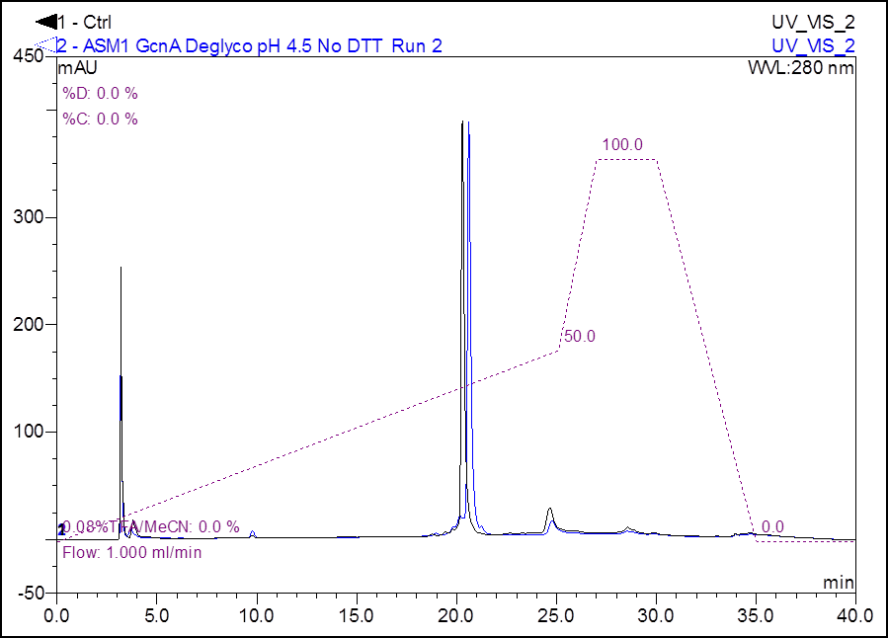

Figure S2. Elution profiles (280 nm) of ASM1 (black) and enzymatically (GcnA) mono-*O*-deglycosylated ASM1 (blue). Retention time on a Jupiter 5 μm C18 300 Å, 250 x 4.6 mm column increases slightly due to the GcnA-catalysed release of the hydrophilic GlcNAc moiety.



(a)

Monoisotopic mass = 1614.9676

- 1x GlcNAc

- 1x GlcNAc

- 1x GlcNAc

- 2x GlcNAc

- 2x GlcNAc

- 2x GlcNAc



(b)

Monoisotopic mass = 1547.2833

Figure S3.

(a) Mass spectrum of ASM1 after incubation with the *N*-acetyl--D-glucosaminidase GcnA overnight at room temperature. Inset shows the (M+3H)3+ ion of the mono-*O*-deglycosylated species.

(b) (M+3H)3+ ion of the di-*O*/*S*-deglycosylated species. Monoisotopic m/z of the triply charged ion (1547.28) corresponds to a mass of 4638.82 Dawhich matches the theoretical mass of non-glycosylated ASM1 with two disulfide bonds (4638.8142 Da).



ASM133-43

ASM11-32

Figure S4. RP-HPLC elution profiles (A280 nm) of ASM1 (black) and a tryptic digest of ASM1 (blue).

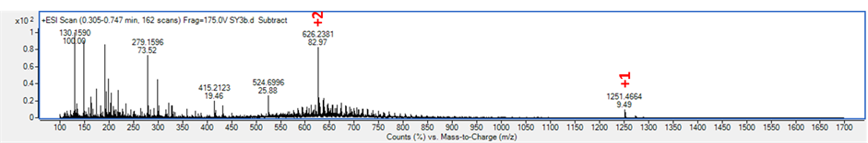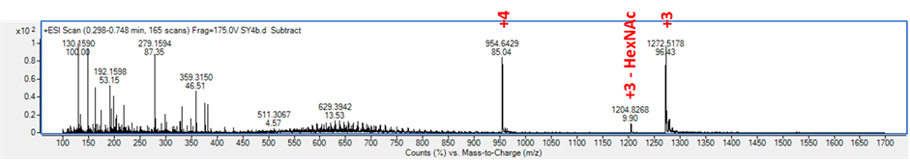

(a)

(b)



Figure S5. Mass spectrum of GccF after incubation with trypsin at 37 °C for 4 h.

(a) (M+H)+ ion of the C-terminal tryptic fragment (residues 33-43) bearing one HexNAc residue. The monoisotopic m/z (M+H)+ of 1251.466 for the singly charged ion matches the theoretical mass (1250.462 Da). Note the small peak at m/z 524.6996. This corresponds to the (M+2H)2+ ion of the de-*S*-HexNAcylated species, probably formed due to MS fragmentation.

(b) The (M+3H)3+ ion of the N-terminal tryptic fragment (residues 1-32) with two disulfide bonds and a single HexNAc residue. The monoisotopic m/z of 1271.85 for (M+3H)3+ (see inset) corresponds to 3812.53 Da for the peptide, which closely matches the 3812.5213 Da theoretical mass. Note the small peak at m/z 1204.83. This corresponds to the (M+3H)3+ ion of the *O*-deglycosylated species, probably formed due to MS fragmentation.

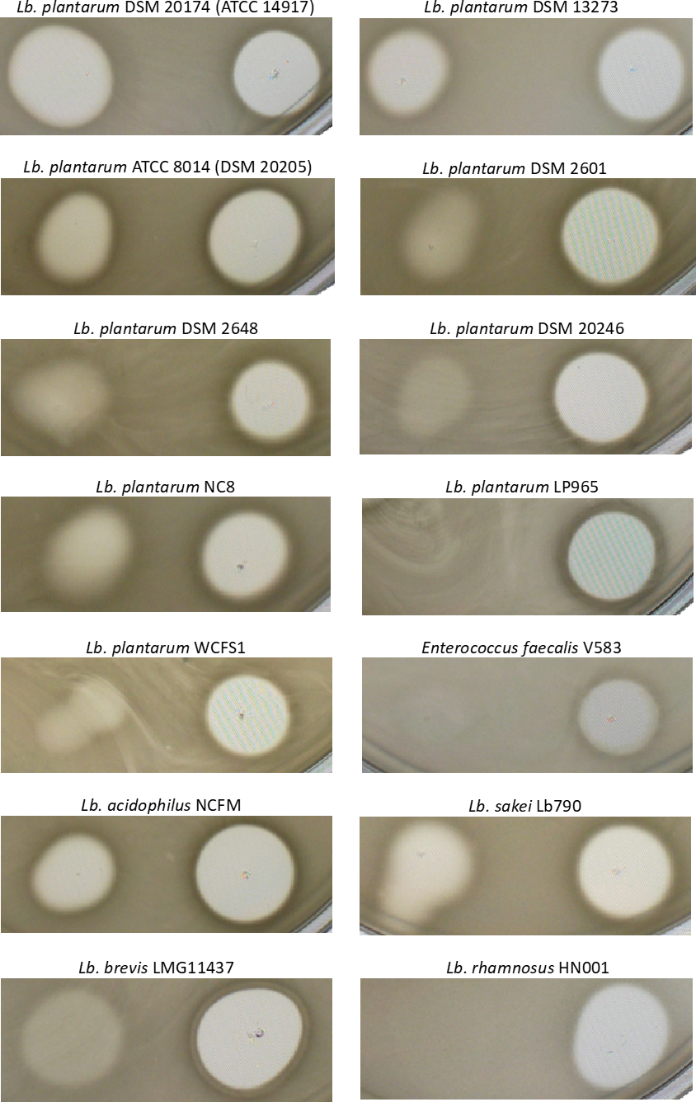

Figure S6. Selected MRS (or, for *Enterococcus faecalis* V583, TSB) 1% agar indicator plates. For each panel, any zone of growth inhibition on the left is due to 4 µM purified ASM1 (5 µL), and the zone of growth inhibition on the right is due to 2% (w/v) nisaplin (5 µL).

**Genetic analysis**: Manual DNA sequencing (primer walking) beyond the *asm* genes, and subsequent next-generation sequencing of *L. plantarum* A-1 genomic DNA, showed that the *asm* gene cluster is located on a 11,905 bp plasmid (Fig. S9; GenBank accession KU896918). Other ORFs are likely to encode proteins with roles in plasmid mobilisation and replication, *e.g*. relaxase superfamily protein MobA, and Rep3 superfamily initiator replication protein RepB, both found in many *Lactobacillus* plasmids. Other plasmid DNA elements include 60 bp imperfect/partial direct repeats that separate the bacteriocinogenic and replication regions of the plasmid, and a cluster (upstream of *repB*) of two AT-rich regions (associated with the plasmid origin of replication) and 3.8 22-bp direct tandem repeats (iterons) characteristic of class A theta replicons.



Figure S7a. pA1_ASM1-cured *Lb. plantarum* A-1 colonies identified by overlaying with ATCC 14917.

*Lb. plantarum* A-1 was cultured in MRS medium (Merck) supplemented with 0.2 µg/mL novobiocin (a plasmid-curing agent), for 48 hours at 40˚C (final O.D.600 nm ~3). The culture was then diluted 5x105 – 2x106-fold in MRS medium and 50 µL of the diluted cells were embedded in 10 mL MRS medium (40˚C) solidified with 1% agar. After 40 hours incubation at 30˚C, colonies were visible and the agar was overlayed with 14 mL MRS 1% agar (40˚C) containing 70 µL of a stationary-phase culture of the ASM1 indicator strain *Lb. plantarum* ATCC 14917. Incubation overnight at 30˚C revealed ~15% of colonies had a severely attenuated bacteriocinogenic phenotype, *e.g.* colonies N2, N5 and N6.



Figure S7b. ASM1-sensitivity of *Lb. plantarum* A-1 wild-type and novobiocin-treated strains.

5 µL volumes of the indicated solutions were applied to MRS agar plates seeded with the wild-type A-1 strain, or strains N2 and N5 generated by novobiocin treatment. Strains N2 and N5, but not the wild-type strain, were inhibited by ASM1. All strains were inhibited by nisin in the nisaplin solution.



Figure S7c. PCR amplification of regions of pA1_ASM1 from wild-type and ASM1-minus strains.

Colony PCR on the *Lb. plantarum* A-1 wild-type strain, and on six ‘ASM1-minus’ strains (N1-6) generated by novobiocin treatment, gave the expected PCR products for the wild-type strain, but not for the novobiocin-treated strains (N1-6) which all had greatly attenuated antibacterial activity. L, 1 Kb Plus DNA Ladder.

**A**) PCR primers A1_FinalPCR Fwd: 5’- CAAGCTCCACAACCACATTATC

A1_FinalPCR Rev: 5’- CGATTGTAAGACTGTCAACACTTT

These primers amplify part of the *mobA* ORF in the plasmid replication/mobilisation region of pA1_ASM1. Expected PCR product size is 591 bp on a 1.5 % agarose gel.

**B**) PCR primers AsmA_Nde_F: 5’- GGTCTTCATATGAAGAATAAAACAACTCATACCG

A1_gDNA_GTase_direct: 5’- TTCTTCGTGAACCATTTCTTGTA

These primers amplify part of the *asmA* (GTase) ORF in the bacteriocinogenic region of pA1_ASM1. Expected PCR product size is 723 bp on a 1.0 % agarose gel.





Figure S8. The *Lb. plantarum* A-1 genome encodes a bactofencin-like bacteriocin, ASM2.

*Lb. plantarum* A-1 nucleotide sequence and deduced amino acid sequence of the bactofencin-type **ASM2** precursor peptide, aligned with (i) another (unannotated) bactofencin-type bacteriocin encoded on the 31,304 bp plasmid pL1277-4 (GenBank accession CP017367) in *Lb. plantarum strain* **TMW** 1.277, isolated from palm wine, and (ii) **bactofencin A** produced by *Lb. salivarius* DPC6502 [3]. All three mature peptides feature a highly cationic region (immediately after the double glycine leader peptide cleavage site in the precursor peptide), and two conserved cysteine residues known to form a disulfide bond in bactofencin A. In both of the *Lb. plantarum* gene clusters predicted to encode a bactofencin-type bacteriocin (ASM2 and TMW), the bactofencin structural gene is *immediately* adjacent to a proteolytic ABC transporter (peptide exporter) gene, and these two genes are divergently transcribed. A map of the ASM2 putative gene cluster is shown below the multiple sequence alignment.

References

1. Stepper, J., Shastri, S., Loo, T. S., Preston, J. C., Novak, P., Man, P., Moore, C. H., Havlícek, V., Patchett, M. L. & Norris, G. E. (2011) Cysteine *S*-glycosylation, a new post-translational modification found in glycopeptide bacteriocins, *FEBS Letters* **585**, 645-650.

2. Hata, T., Tanaka, R. & Ohmomo, S. (2010) Isolation and characterization of plantaricin ASM1: a new bacteriocin produced by *Lactobacillus plantarum* A-1, *International Journal of Food Microbiology.* **137**, 94-9.

3. O'Shea, E. F., O'Connor, P. M., O'Sullivan, O., Cotter, P. D., Ross, R. P. & Hill, C. (2013) Bactofencin A, a New Type of Cationic Bacteriocin with Unusual Immunity, *mBio.* **4**, e00498-13.